Exploratory Data Analysis Report: Food Processing & Nutrition Profiling
Internship Week 1 Deliverable | Dataset: 80 Cereals Nutritional Records

1. Executive Summary & Problem Scope
This exploratory data analysis examines the 80 Cereals dataset containing 77 commercial products. Our findings demonstrate a strong trade-off between sugar and ratings, along with shelf merchandising strategies.

2. Data Hygiene & Preprocessing
Handled missing values (-1) in carbo, sugars, and potass via median imputation. Standardized categorical manufacturer mappings.

3. Univariate Analysis
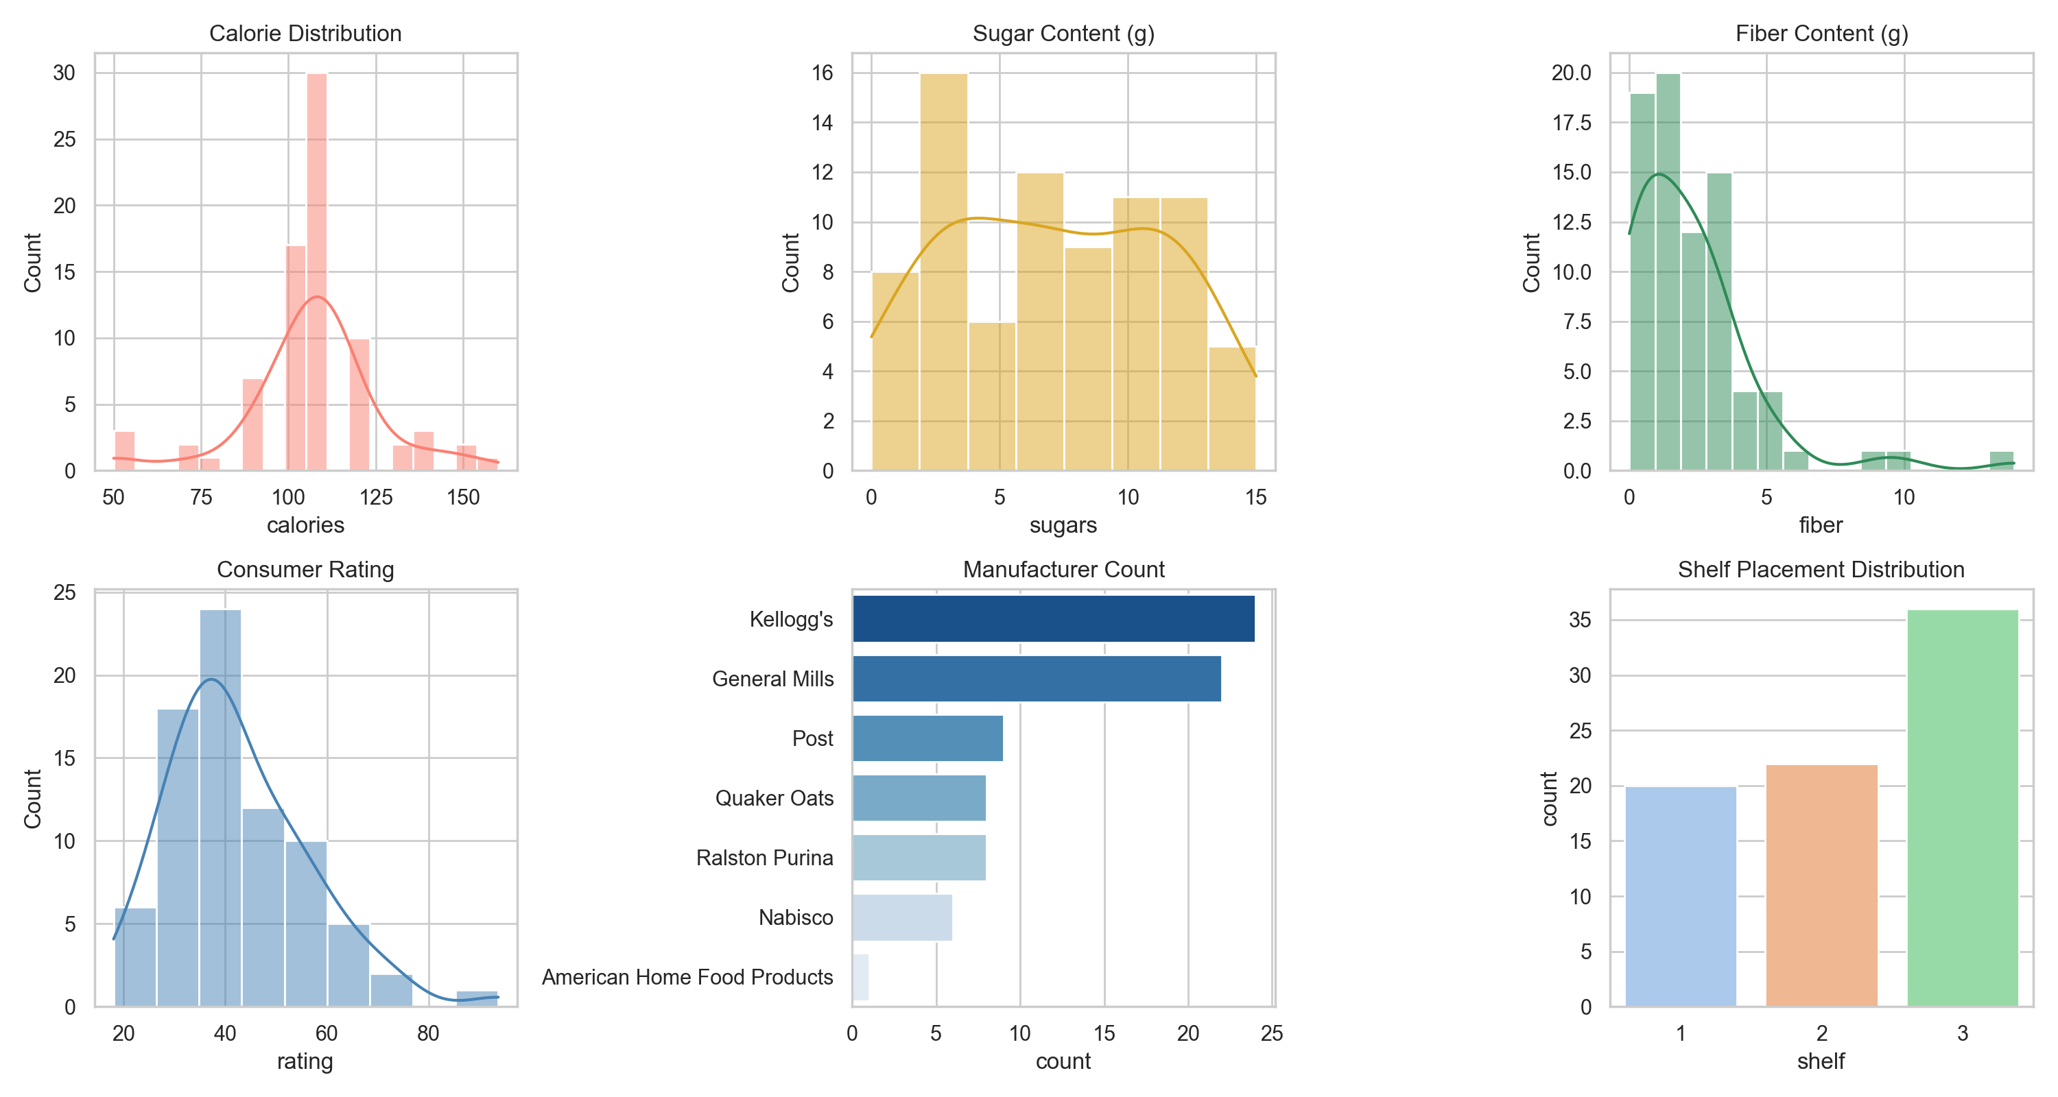

4. Bivariate & Multivariate Analysis
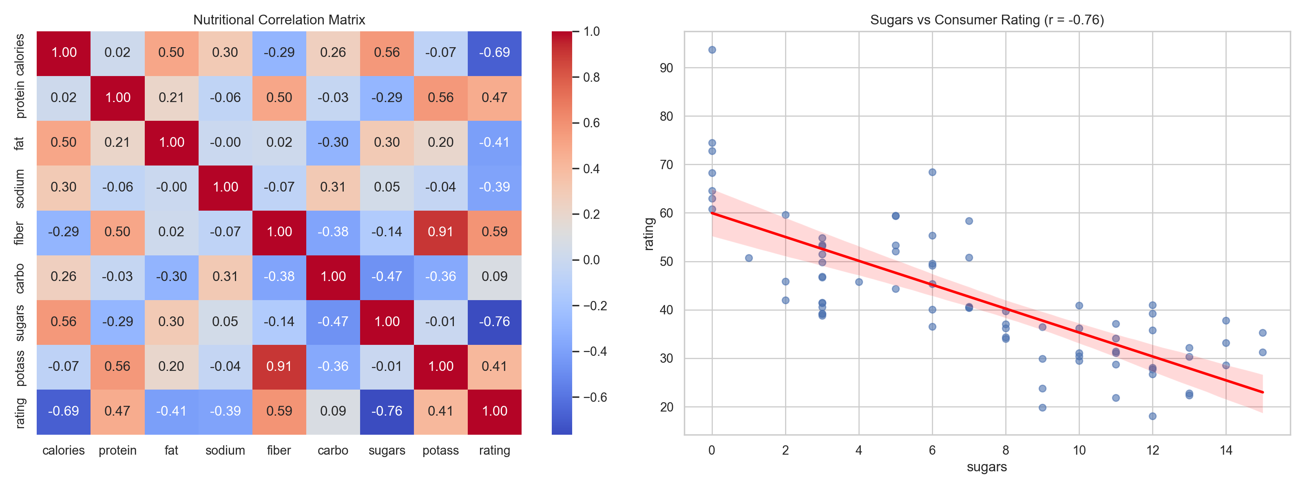
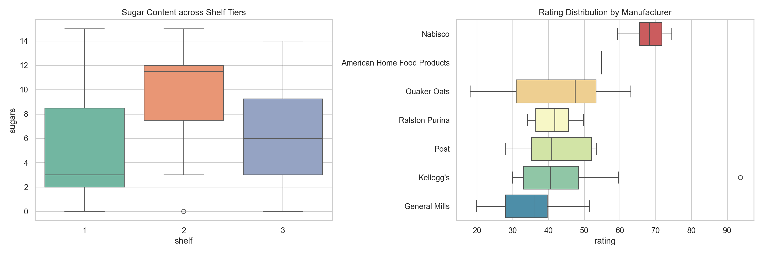

5. Key Insights & Conclusion
• Sugar negatively impacts nutritional rating with r = -0.76.
• Shelf 2 holds products with the highest sugar levels, targeting kids.
• Nabisco products hold the highest median rating due to whole grain content.

